C:\Users\paige.macqueen\AppData\Local\Microsoft\Windows\Temporary Internet Files\Content.IE5\DRX5H1UU\MC900352218[1].wmfC:\Users\paige.macqueen\AppData\Local\Microsoft\Windows\Temporary Internet Files\Content.IE5\DRX5H1UU\MC900352218[1].wmf

It’s easy in the winter to spend more time in front of screens. As a parent, it’s your decision on what limits to set for your child. Monitoring what they are watching and how it fits into your family’s lifestyle is key. Also, watch how your child/teen acts during and after watching TV, playing video games, or hanging out online. Below are a few facts and guidelines to help you in setting screen time limits.

Paige MacQueen, R.S.W. January 2015

The School Social Worker Spotlight

**FACTS:**

**Children are spending an average of seven hours a day on various screen time**.

**7 hours!**

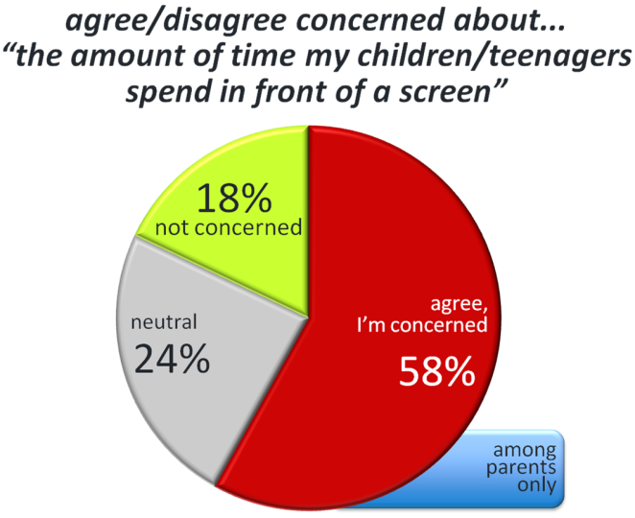**Studies have shown that excessive screen time can lead to attention problems, school difficulties, sleep and eating disorders, and obesity. In addition, the Internet and cell phones can provide platforms for illicit and risky behaviors.**

**Poll of parents concerned about the amount of time their child/teen spends in front of a screen:**

**How to Set Screen Rules That Stick**

**For Elementary and Middle Schoolers:**

* **Set a timer or some other cue that says "time to stop" and then stick to it!**
* **Help them balance their day.** Kids this age need guidance from you on a daily plan that includes a little bit of time for everything.
* **Practice what you preach.**  Model the media behavior that you want your kids to follow.

**For High Schoolers:**

* **Help them make good choices.** You still have a say in what they see, hear, and play. Help them choose quality shows, games, and movies.
* **Crack down on multitasking.** High school kids tend to text, Facebook, and listen to music all at once - especially when they're supposed to be doing homework. This practice actually reduces the ability to concentrate and focus.
* **Find ways to say "yes."**Look for movies they *can*watch. Find games you're OK with. If your teens ask to see something you don't approve of, help them find alternatives through websites like www.commonsensemedia.org.



**References:**

*<https://www.commonsensemedia.org/screen-time/how-much-screen-time-is-ok-for-my-kids>

*<http://www.aap.org/en-us/advocacy-and-policy/aap-health-initiatives/Pages/Media-and-Children.aspx#sthash.cM8dXJsY.dpuf>

**\*http://techmedianow.blogspot.ca/2012/10/are-kids-spending-too-much-time-in.html**